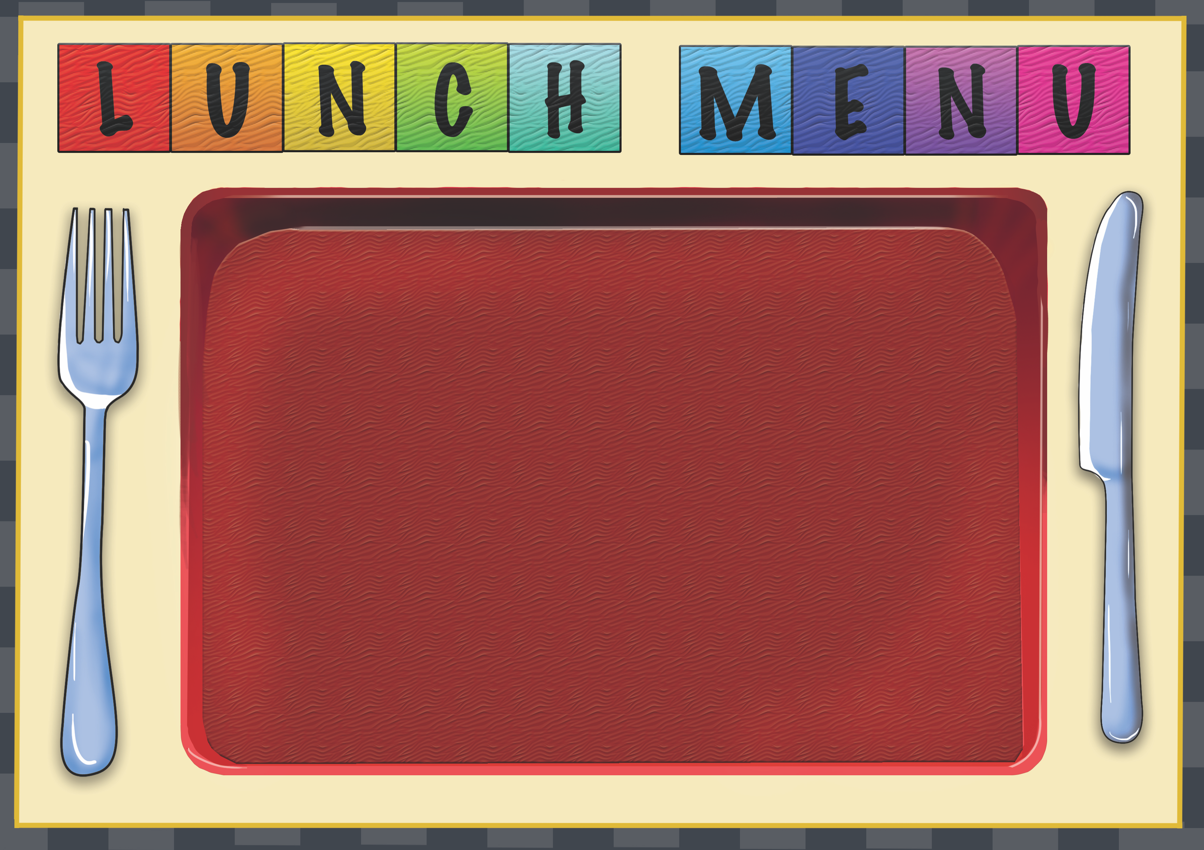
Week  2 | Dish of the Day | Dish of the Day 2 | Vegetables  Or Salad | Potato  or Rice | Dessert
Monday | Chicken Samosa  2,7,9,10,13 | Quorn & Sweet Potato Chili  2,13,14 | Salad | rice | Homemade Biscuit or Cake  or fruit
Tuesday | Creamy Chicken Pasta with Spinach  2,4,6,7 | Pizza Slice  2,7 | Sweetcorn | Garlic bread  2,6 | Homemade Biscuit or Cake  Or fruit
Wednesday | Beef Cottage Pie  1,7 | Quorn Sausage Roll  1,2,4,13 | Mixed Veg | Diced potato | Homemade Biscuit or Cake  Or fruit
Thursday | Cheese & Tomato Panini  2,4,7 | Curried Quorn Pasty  2,4,6,7,9,13 | Sweetcorn | Roasted New Potato | Homemade Biscuit or cake  Or fruit
Friday | Jacket Potato  With a choice of fillings  4,5,7 | Macaroni Cheese  2,7 | Salad | Garlic bread  2,6 | Homemade Biscuit or Cake  Or fruit

