**Mathematics**

**This half term we will develop our understanding of: money, fractions and time.**

**The children will participate in the whole school money week. We will continue with fractions learning how to add and subtract fractions, as well as, finding equivalent fractions. The children will then learn how to tell time. They will know the difference between am and pm and be able to read a digital clock.**

**Science**

This term we are learning about light and how shadows are formed. We will discuss the dangers of the sun and ways we can protect our eyes. The children will explore how the size of shadows change.

**English**

**Title: Playscripts**

**Key Text: Jeremy Strong Romans on a Rampage.**

**Writing: Create innovated playscript**

**Spellings, Punctuation & Grammar (SPAG): Homophones, apostrophes for possession and contraction, adverbs, subordinating conjunctions, plurals and perfect form of verbs.**

**Reading: Character inference, intonation and read a range of plays.**

**RE**

How do festivals and family life show what matters to Jewish people?

The children will take part in an RE day and will have a special visitor.

**Accelerated Reading**

* Pupils need to read at home every night and bring in their diary signed daily.
* They can then quiz in school
* These quizzes help to assess and improve your child’s reading age.

**Year 3**

**Summer 1**

PE is on a **Wednesday**

Please ensure pupils come into school in the school PE kit.

Reading books can be changed as needed and accelerated reading quizzes completed.

Homework expectation: Daily reading/ times tables and spellings. (Reading diaries to be signed)

**MFL**

Our topic this term is ‘Les Quatre Amis’ (The Four Friends).  
The children will be exploring the feminine and masculine forms.

**Music**

Our unit is called "In the Hall of the Mountain King" and we will be focusing on playing percussion instruments and writing graphic scores.

Computing



The children will be learning about email and how to be safe when sending and receiving emails.

**PSHE**

Our topic this term is Relationships.

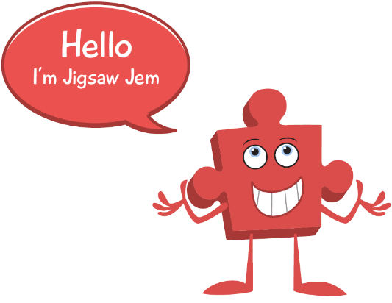

**PE**

This term Year 3 will be working with Primary Reds from Manchester United.

**History**

In History this term we will be exploring the Roman Empire and the impact it had on Britain. The children will learn about Julius Caesar and his attempted invasion. We will discuss the successful invasion by Claudius and view Hadrian’s wall.

**Art**

Our topic this term is Formal Elements Art. We will be studying simple shapes and geometry in everyday objects. The children will then work with wire to create a fish. Finally, the children will explore shading.

1. **Maths task:**

**Colour in different fractions. Can you draw some of your own shapes and shade different fractions.**

**4. Topic task:**

**Write a diary entry as if you were a Roman soldier. How do you feel? What is your daily routine? Did you enjoy invading other countries? Think about the features of a diary entry – you must write in past tense and 1st person.**

**3. English task:**

**Use a popular fairy tale like Red Riding Hood and change the main the character or where it is set or make up your idea and write your own playscript. Be imaginative!**

**2. Creative task:**

**Go on a shape hunt around your house. Create an art piece using the shapes you found in your house. It can be as creative as possible and may not be a drawing of an actual object or thing but art can sometimes be whatever you want it to be! So enjoy…**

**5. Topic task:**

**Go outside and make different shadows! Draw the shadows you created. Then go on a light source hunt around your house… what did you find? Write down the items.**

**Homework:**

Please work through the boxes in order and complete each week.

Hand these in on a Friday for your teacher to celebrate your amazing work.

**Year 3**

**SUMMER 1**

**Homework**

**Year 3**

This half term our class text is Jeremy Strong Romans on a Rampage

**To help familiarise yourself with these words you can:**

* read the words and ask an adult to check that you have read them correctly.
* practise spelling these words correctly.
* ask an adult or look up the meaning in a dictionary.
* try to say or write these words in a sentence.
* look for these words in other texts.

sauntering

crestfallen

dozen

peevish

smithereens

puny

marvel

scornfully

dismissive

bleating

eavesdrop