**English**

**Text:** ‘Prince Cinders’ by Babette Cole

**Writing:** We will study this novel and use it as inspiration for our own writing based on similar themes and events.

We will compare the story with the tale of Cinderella.

**Spellings, Punctuation & Grammar: ​**Ww will focus on sentence structure and using the correct punctuation. Children will then learn how to extend their sentences using and, because and so.

**Reading:** Please read daily at home with your child.  Guided reading will be taught daily using RAMP activities.

**Mathematics**

**This half term we will develop our understanding of:**

**Addition and Subtraction:**

To add and subtract across 10.

10 more 10 less.

Add and subtract 2-digit numbers

Comparing addition and subtraction statements

**Shape:**

2D and 3D shapes.

**Place value: Within 20**

**Science**

**Use of everyday materials**

We will continue to explore the properties of everyday materials. We will learn about how different things are made, for example, paper.

**RE**

Christianity

We will learn where stories of Jesus come from and why Christmas is special to Christians.

**Year 2**

**Autumn Term 2**

PE is on Monday and Thursday (Rabbits)

Monday and Tuesday (Otters)

Please ensure pupils come into school in the school PE kit.

Reading books can be changed as needed and accelerated reading quizzes completed.

Homework expectation: Daily reading/ times tables and spellings. (Reading diaries to be signed)

**Phonics**

The children will participate in daily phonics and SPAG activities.

**Music**

**Ho, Ho, Ho**

We will develop our listen, appraising and singing skills.

Computing



* We will use Purple Mash to learn about online safety and to create spreadsheets.

2PaintaPicture

**Accelerated Reading**

* Pupils need to read at home every night and bring in their diary signed daily.
* They can then quiz in school
* These quizzes help to assess and improve your child’s reading age.

**PSHE**

Celebrating Difference

Using the Jigsaw scheme of work children will discuss and share their feelings about the year ahead.

**PE**

Invasion Games​

We will be developing our understanding of ‘Invasion Games’ including attacking and defending skills.

Dance

We will be learning to dance on our own, with partners and in groups.

**History**

**The Great Fire of London**

How do we know about the Great Fire of London?

What happened after the Great Fire of London?

We will learn more about the timeline of the Great Fire of London.

**DT**

Food: A Balanced Diet

* Children will learn about the food groups to understand a balanced diet to develop a healthy wrap.

Textiles: Pouches

* Children will learn to sew a running stitch ready to design, make and decorate a pouch using a template.

1. **Maths task:**

Use objects or draw a number line to help you.

**4. Topic task:**

**History**

Can you make a picture of the Great Fire of London? You can be as creative as you can!

Use felt tips or even paint!

**3. English task:**

Create a storyboard of the story of Prince Cinders. Draw pictures and write what happened.

**2. Creative task:**

Make a model of a building in London using recycled materials.

5. **Science:**

Find objects around the home that are made from the same material.

Write what the material is and draw them!

Can you find objects made from

Plastic? Rubber? Glass? Wood? (Remember to ask an adult first)

**Homework:**

Please work through the boxes in order and complete each week.

Hand these in on a Friday for your teacher to celebrate your amazing work.

**Year 2**

**Autumn 2**

**Homework**

**Year 2**

This half term our class text is

Prince Cinders

**To help familiarise yourself with these words you can:**

* read the words and ask an adult to check that you have read them correctly.
* practise spelling these words correctly.
* ask an adult or look up the meaning in a dictionary.
* try to say or write these words in a sentence.
* look for these words in other texts.

fiction

gorilla

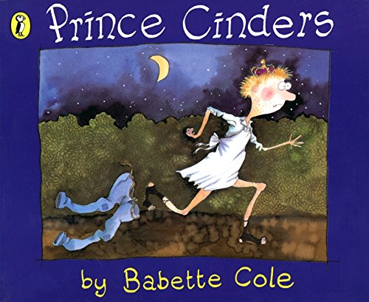

sneered

fairy

chimney

teasing

scruffy

midnight

luxury

proclamation

prince