**PE**

**Strike and Field:**

This half term we will use running, jumping, throwing and catching in order to play competitive games. We will apply basic principles suitable for attacking and defending.

**Science: Electricity**

We will study electricity and electrical components within a circuit. We will compare and give reasons for variations in how components function. Use recognised symbols when representing a simple circuit in a diagram.

**English**

**Text:** Wonder

**Writing:** To write in a range of styles including, formal, informal, poetry and novel writing.

**Spellings, Punctuation & Grammar (SPAG):**  Varied clauses, parenthesis, using punctuation correctly.

**Reading:** Reading at home everyday.

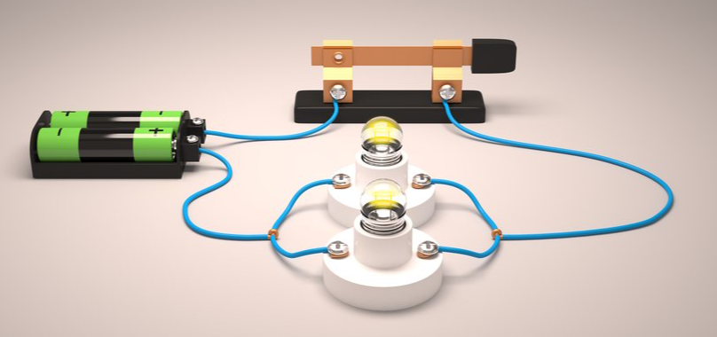

**Reading interventions**

SHINE Interventions

The children will have small group work interventions based on gaps identified in their termly assessments. These will use focused questions on: vocabulary, retrieval and inference.

**Accelerated Reading**

* Pupils need to read at home every night and bring in their diary signed daily.
* They can then quiz in school
* These quizzes help to assess and improve your child’s reading age.



**Year 6**

**Chameleons and Tortoises**

PE is on a Tuesday.

Reading books can be changed as needed and accelerated reading quizzes completed.

Homework expectation: Daily reading/ times tables and spellings. (Reading diaries to be signed)

**MFL**

**Monter un Café**

**(Setting Up a Café)**

Junior Jam will be teaching our French lessons.

**Maths at Home**

Times Tables Rock Stars



**Geography**

**Our Changing World:**

This half term we will describe and understand key aspects of human and physical geography. We will name and locate counties and cities of the United Kingdom and compare the landscape to other countries.

**PSHE**

**Relationships and Changing Me**

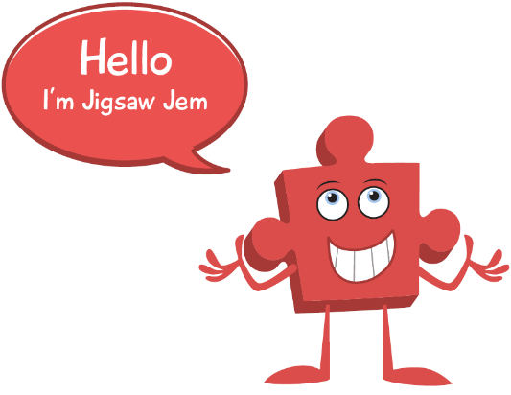

**DT-**

**Electrical Systems:**

Generate, develop, model and communicate our ideas through discussion, research and annotated sketches to design and create our own steady hand game.

Computing

**Network Engineers:**

Junior Jam will be teaching our computing lessons.



**Mathematics**

This half term we will develop our understanding of:

* Ratio and Proportion
* Statistics with a focus on Line and Pie charts
* Geometry (co-ordinates)
* Properties of Shape including angles and nets of 3D shapes.
* Problem solving and reasoning

Division