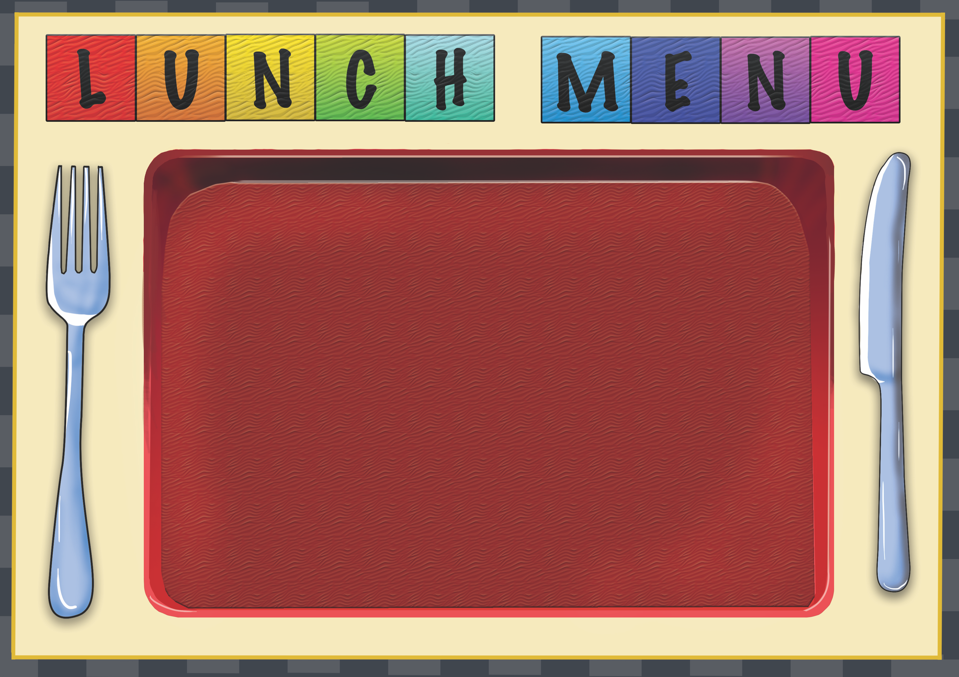
Week 1 | Dish of the Day | Dish of the Day 2 | Vegetables  Or Salad | Potato  or Rice | Dessert
Monday | Beef sausage with Mash Potato  1,2 | Spring rolls with Noodles 1,2,7,9,10,13 | peas | Mash Potato | Homemade Biscuit or Cake
Tuesday | Fish Fingers  2,4,5,7 | Quorn Pasta Bolognaise  1,2,4,7,13 | Baked Beans | Garlic Bread  2,6  Herb New Potato | Homemade Biscuit or Cake
Wednesday | Meat and Potato Pie  1,2,4,7, | Quorn Curry with Rice  1,2,4,9 | Mixed Veg | Rice | Homemade Biscuit or Cake
Thursday | Beef Chili with Wedges  1,2, | Cheese & Tomato Panini  2,4,7 | Sweet corn | Potato Wedges | Homemade Biscuit or Cake
Friday | Beef Burrito  1,2,7,13 | Macaroni Cheese  1,2,7 | Salad Bar  Available | Roasted new potato  Garlic Bread  2,6 | Homemade Biscuit or Cake

