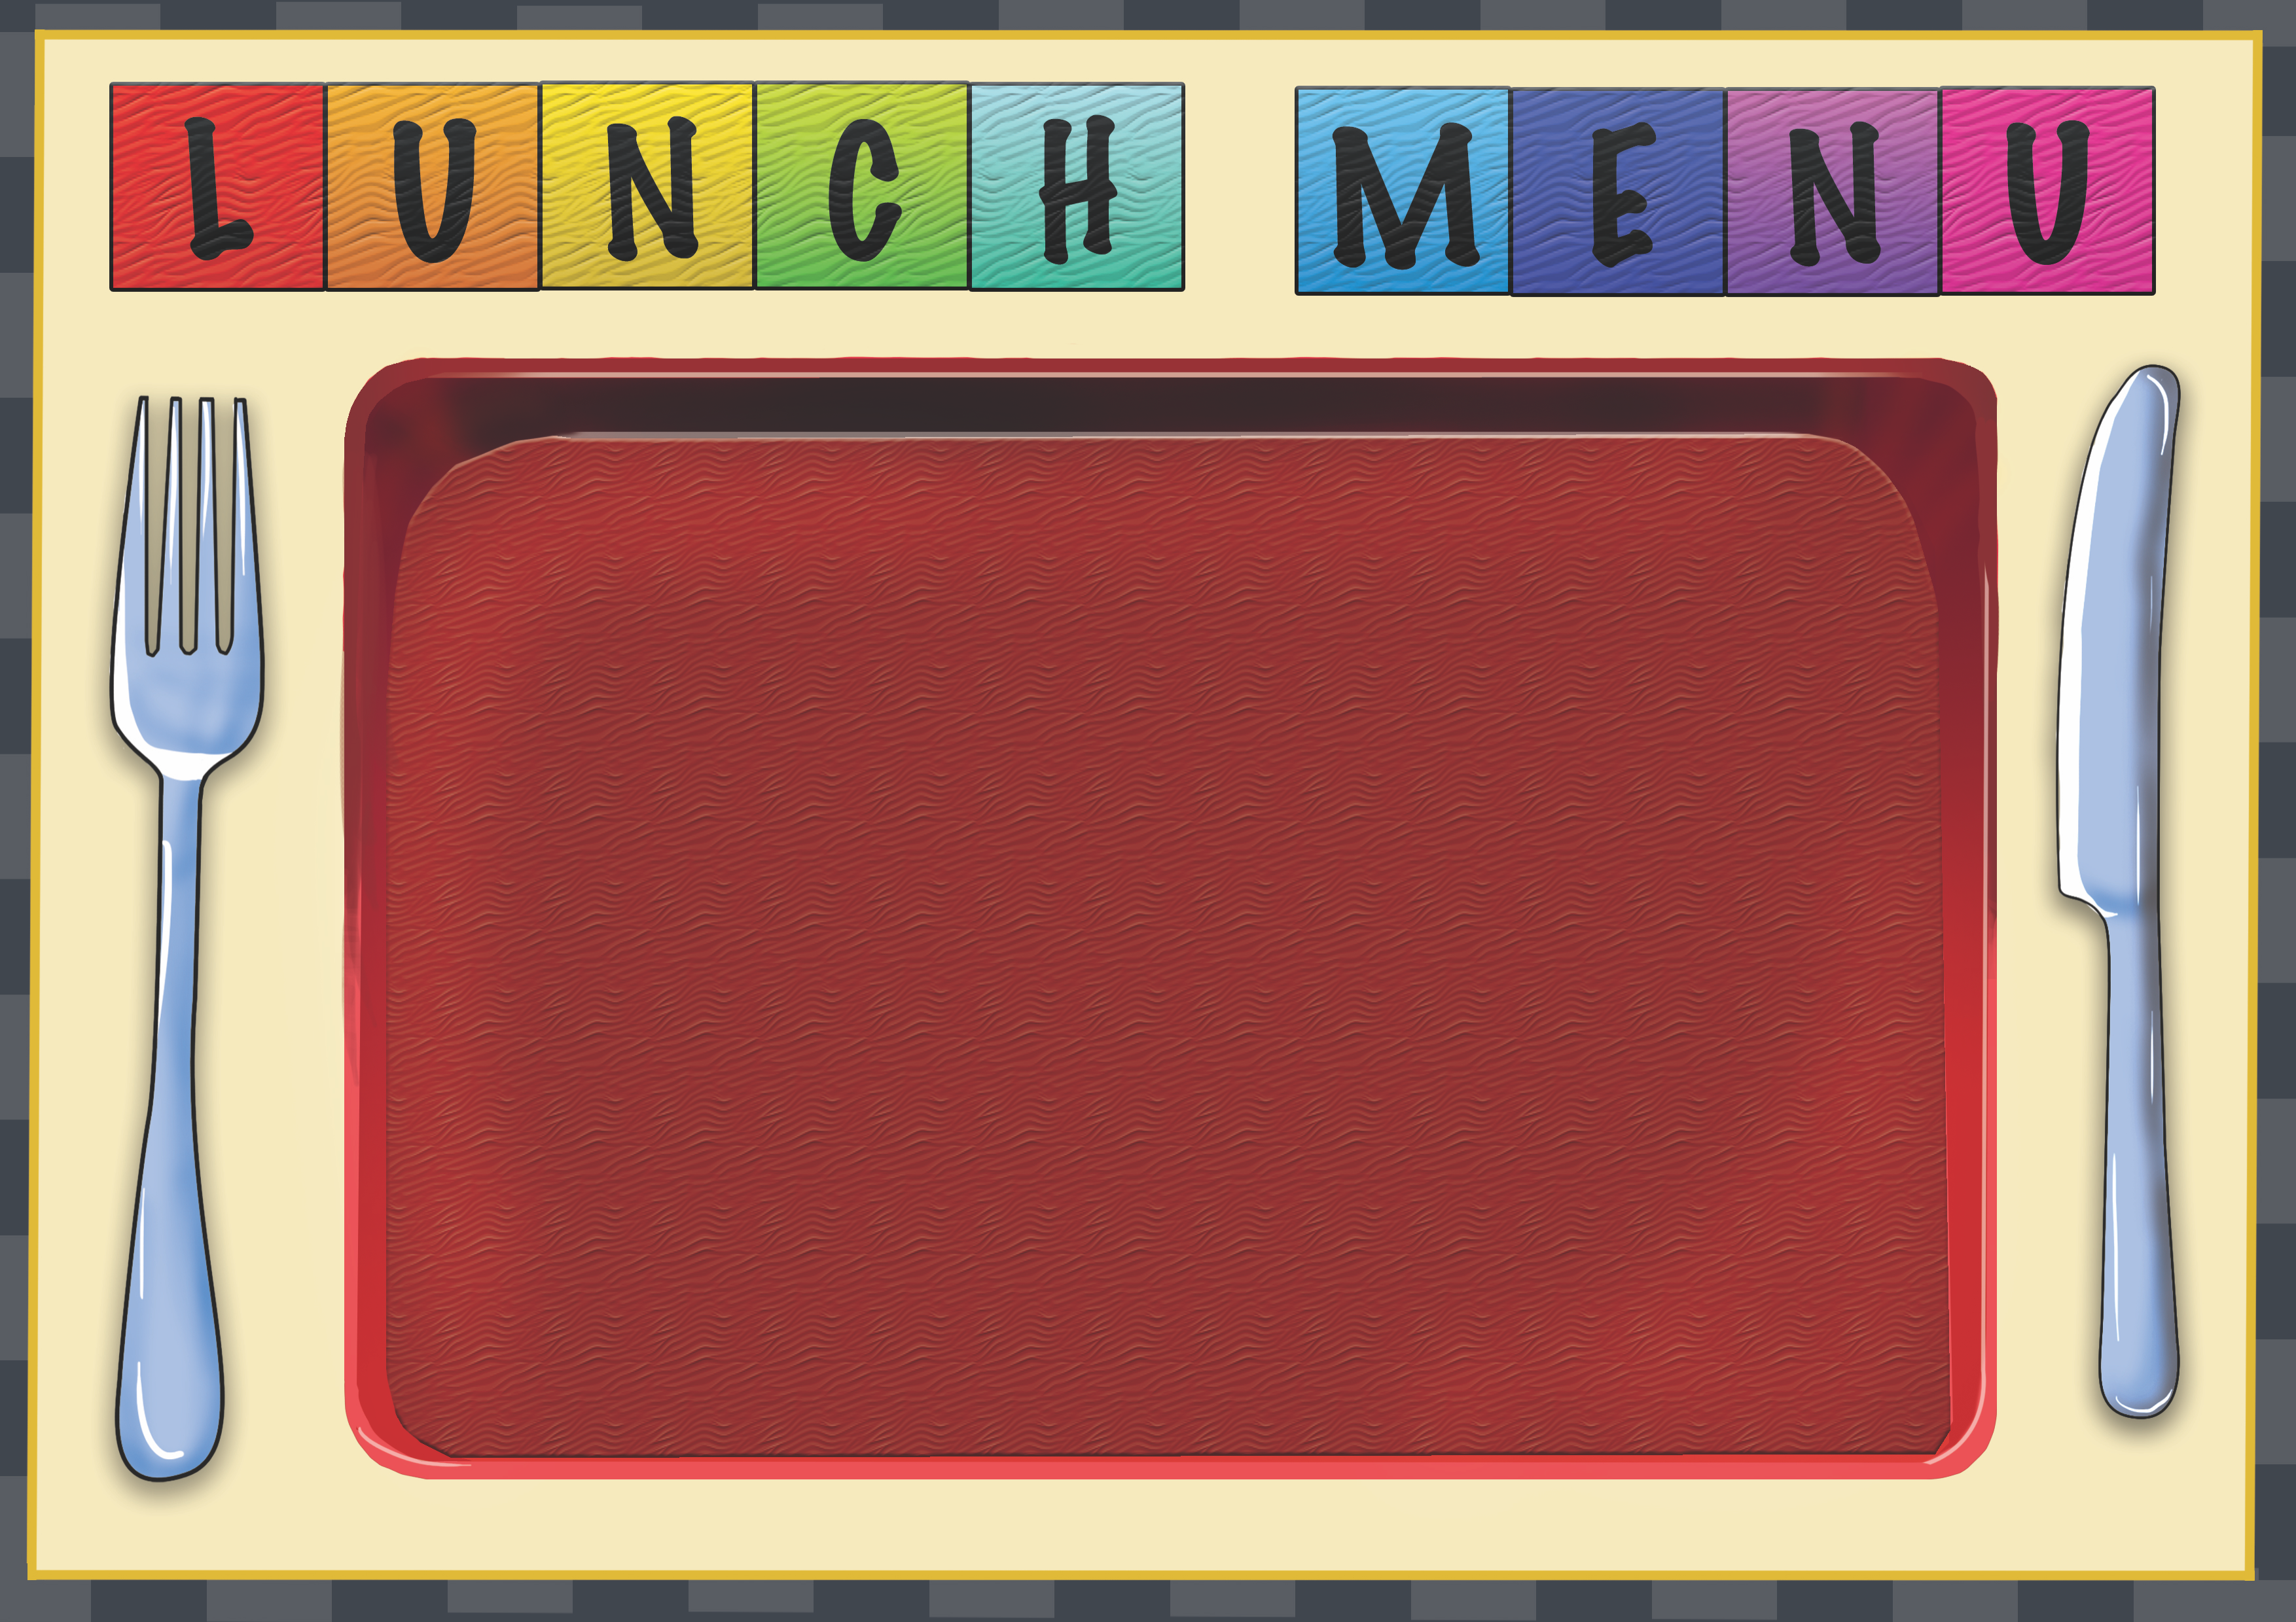
Week 4 | Dish of the Day | Dish of the Day 2 | Vegetables  Or Salad | Potato  or Rice | Dessert
Monday | Tandoori Chicken Thigh  1,6,13 | Macaroni Cheese  1,2,7 | Salad | Garlic Bread  2,6  Rice | Homemade Biscuit or Cake
Tuesday | Roast Chicken  With Gravy  1 | Quorn Chili  1,2,7,13 | Mixed Veg | Roast Potato  Rice | Homemade Biscuit or Cake
Wednesday | BBQ Cheese & Tomato Pasta  2,7 | Beef & Vegetable Pie  1,2,4,7 | Salad | Mash Potato  Garlic Bread  2,6 | Homemade Biscuit or Cake
Thursday | Beef Lasagna  1,2,6,7, | Cheese & Tomato Panini  2,4,7 | Sweet corn | Diced Herb | Homemade Biscuit or Cake
Friday | Fishcake  1,2,4,57 | Chicken & Sweet corn Pizza  2,7 | Salad Bar Available  Baked Beans | Chips | Homemade Biscuit or cake

