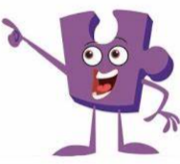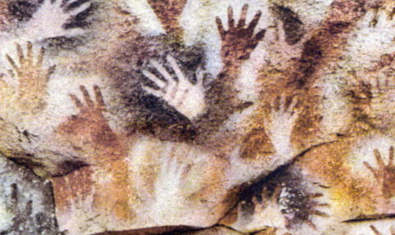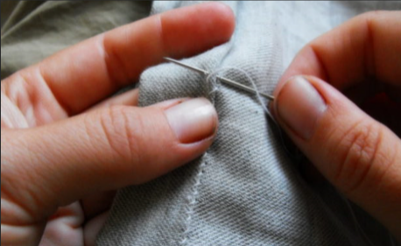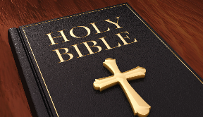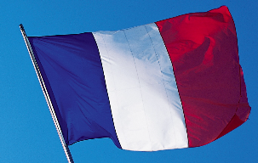

**MFL**

*Moi (All about me)*

Learn basic phrases in French to introduce yourself.

**PSHE**

*Being Me in My World*

The children will create a learning charter for their classroom.

Year 3 Curriculum Map

*Autumn 1*

**DT**

*Textiles – Cushions*

Design an innovative, functional and appealing product that is fit for purpose.

**Art**

*Prehistoric Art*

Drawing, painting and sculpture.

**RE**

*Christianity*

What do Christians learn from the Creation story?

**Computing**

*We are Programmers.*

Design, write and debug programs that accomplish specific goals.

*E-safety.*

**History**

*The Stone Age*

Understand the changes in Britain from Stone Age to Iron Age.

Know which tools were crucial to the survival of early man.

Explain how Skara Brae was discovered.

Greek life

Achievements

Influence on the western world

**English**

*Rock and Roll*

Stone Girl Bone Girl: The story of Mary Anning

by Laurence Anholt

Story on a theme

Poems on a theme

Discussion

Maths

*Number and Place Value*

*Addition and Subtraction*

**Music**

Listen and appraise music from a range of different genres and historical periods.

**PE** 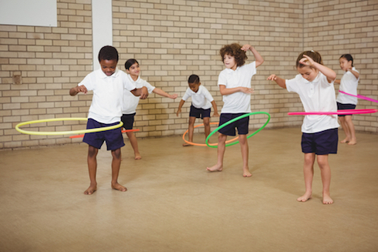

Due to the current restrictions, PE will look a little different for now. Instead of our PE lessons we will be doing:

Class based Yoga, Go Noodle

and adapted Invasion Games.

**Science**

*Rocks*

Grouping and classifying rocks based on appearance and physical properties.

Describe how fossils are formed.

Explore how soil is made.