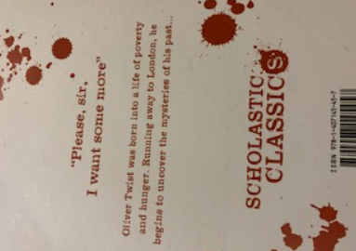

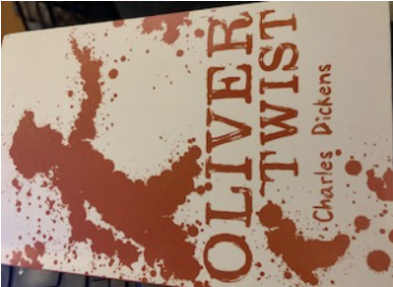e

**English**

**Text:** *Oliver Twist by Charles Dickens*

**Writing:** Chapter with historical settings, dialogue, description, action, play scripts and poetry.

**Spellings, Punctuation & Grammar (SPAG):**  Parenthesis, using word classes, conjunctions and power openers.

**Reading:** Reading at home everyday. Class Novel

MFL

Numbers to 100.

Maths - Home

TT-Rockstar’s

Times tables

**Year 5**

**PE day is on Friday for Giraffes and Zebras**

**Reading books are changed as needed and accelerated reading quizzes completed.**

**Homework expectation: Daily reading/ times tables and spellings. (Reading diaries to be signed)**

**Weekly homework: English, Science, Maths and spelling.**

Maths interventions

Focused number work, times tables and developing mental maths strategies.

Also, setting times table individual targets.

PSHE

Celebrating difference.

Rainbow writing

Intervention.

Focus on improving our sentences working on – verbs, adjectives, adverbs, conjunctions, openers and adding phrases.

Computing

Focus on music this half term.

Accelerated reading.

* Pupils need to read at home nightly and bring in diary signed daily.
* They can then quiz in school
* These quizzes help to assess and improve your child’s reading age.

**Mathematics**

**Multiplication**

**Division**

**Fractions**

**Decimals**

**Percentages**

Division

Reading interventions

Pira gaps (Test used in school) – focused questions on: vocabulary, retrieval and inference.

Some groups are also revising phonics to support them in reading, writing and spelling.

**PE**

**Multi – Sports.**

**(With a sports coach)**

Science

Materials

With a focus on investigating materials. Children are predicting, planning, carrying out a fair test / experiment, recording results and drawing conclusions.