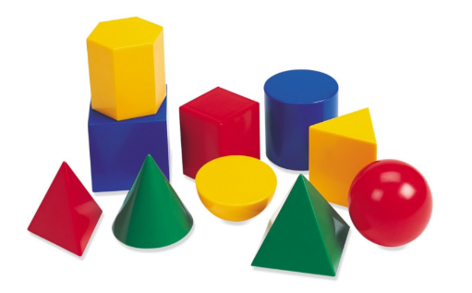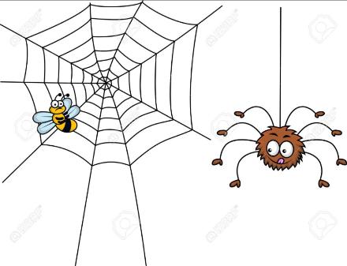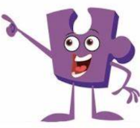

**MFL**

*French*

Names of food

**PSHE**

*Changing Me*

How we change as we grow up.

Year 3 Curriculum Map

*Summer 2*

**DT**

*Structures*

Constructing a castle.

**Art**

*Craft: Materials*

Creating a mood board

Weaving

Tie-dye T-shirts

**RE**

How do festivals and family life show what matters to Muslims?

**Computing**

*Internet Safety*

*Spreadsheets*

**Geography**

*Exploring Eastern Europe*

Using maps, atlases and globes.

Understanding geographical similarities and differences.

Greek life

Achievements

Influence on the western world

**English**

*How does your garden grow?*

Classic Poetry:

*The Spider and the Fly*

Mystery / Adventure / Fantasy Story:

*The Enchanted Wood*

**Maths**

*Measurement: Time*

*Geometry: Properties of Shape*

*Measurement:*

*Mass, Capacity and Temperature*

**Music**

*Bringing us Together*

Singing, playing instruments, composing and improvising.

**PE**

Invasion Games.

Specialist P.E tuition from Primary Reds (Manchester United F.C)

**Science**

*Plants*

Identify and describe the different parts of flowering plants.

Explore the requirements for plants to grow.