# 

**PE**

Due to the current restrictions, PE will look a little different for now. Instead of our PE lessons we will be doing:

* Class based Yoga
* Go Noodle Activities
* Adapted Invasion Games

**PSHE**

**Jigsaw Puzzle Piece**

Celebrating Differences



**English**

**Title – The Great Plague**

**Key Text – The Pied Piper of Hamlin**

**Writing:** Fairytale, poetry.

**Spellings, Punctuation & Grammar (SPAG):**

**Reading:** Reading at home every day.

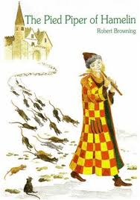

**Science:**

**Sound**

Identify how sounds are made, associating some of them with something vibrating.

Recognise that vibrations from sounds travel through a medium to the ear.

Find patterns between the pitch of a sound and the features of the object that produced it.

Find patterns between the volume of a sound and the strength of the vibrations it produced.

Recognise sounds get fainter as the distance from the sound increases

**Mathematics**

**Measurement:**

Length and perimeter

**Multiplication and division:**

Multiply and divide by 10, 100 and 1000

Times tables

Meerkats and Aardvarks

Children will be expected to read five times a week completing a quiz in school when they have finished their book. Please make sure children have their reading record in school every day.

Homework expectations:

Children will receive homework every Friday and will be due the following Wednesday. They will have four pieces of work an English, Maths, Science and Topic question as well as weekly spellings.

**Reading Catch up:**

Retrieval

Inference

Deduction

**SPaG Catch Up**

Sentence structure

Word classes

Fronted Adverbials

**Times tables:**

Recapping 2, 5, 10s

Learning 3, 4, 6, 7, 8, 9, 11, 12s 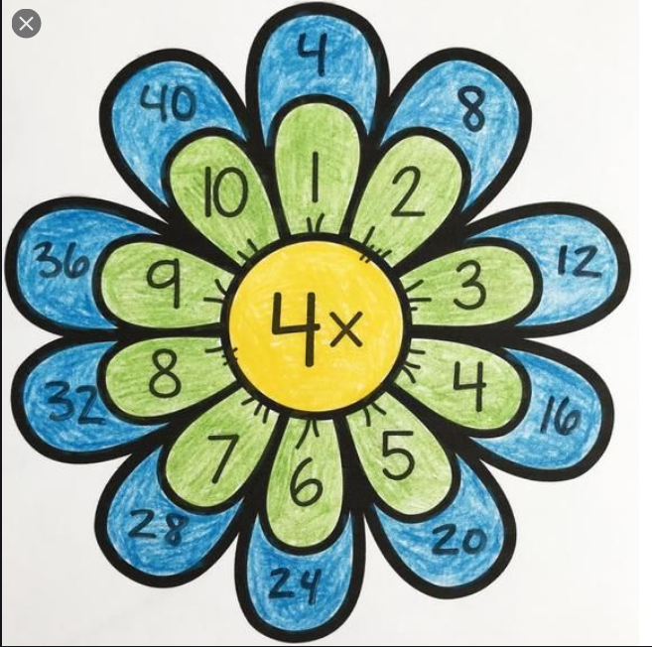

**Computing**

**We Are Toy designers**

Design, write and debug programs that control or simulate physical systems.

Work with various forms of input and

output.

**Maths Catch Up**

Place value

Mental maths

