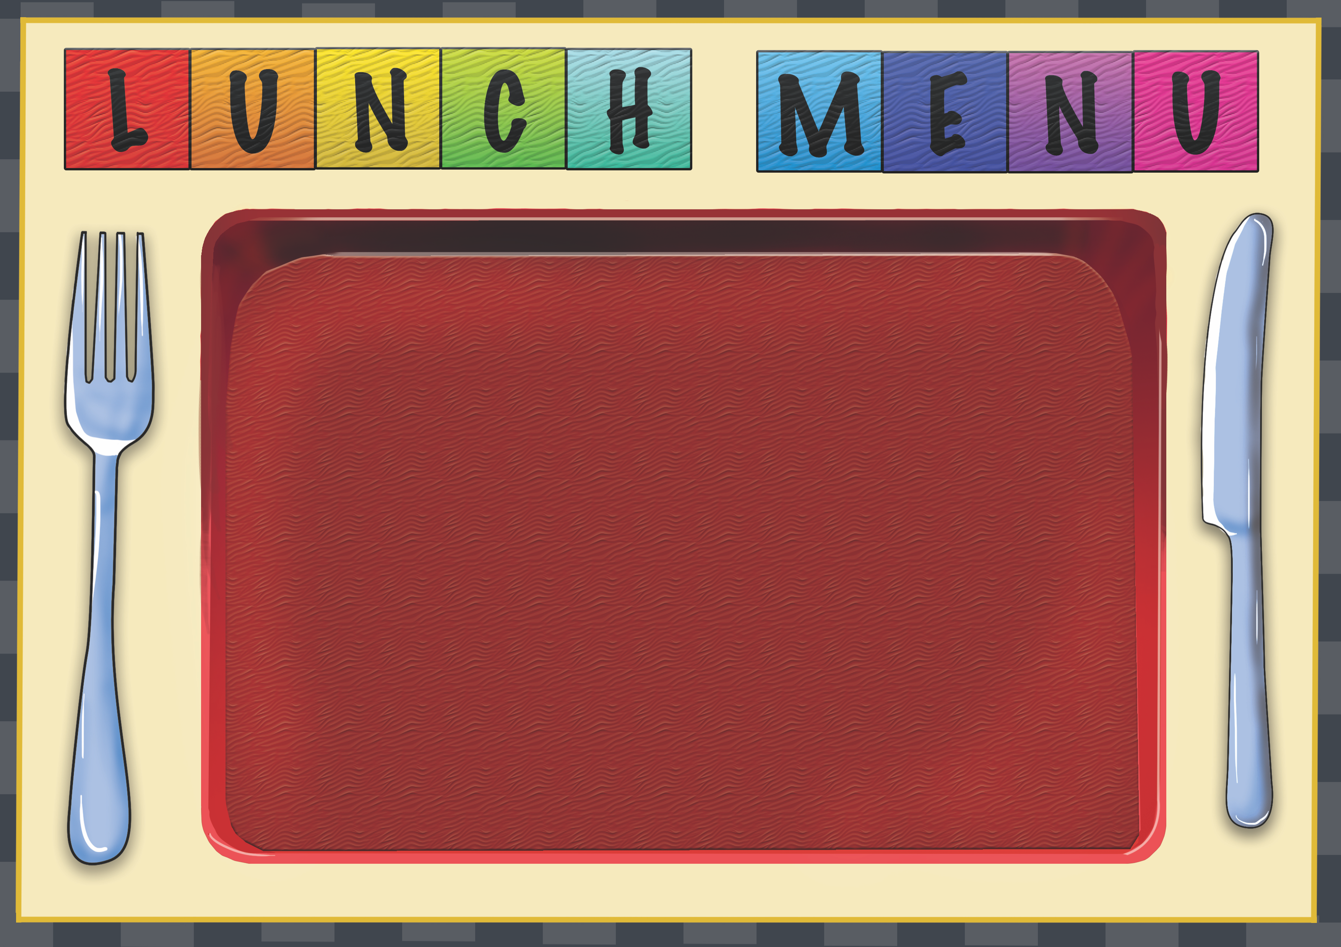
Week 2 | Dish of the Day | Dish of the Day 2 | Vegetables  Or Salad | Potato  or Rice | Dessert
Monday | Chicken Samosa  2,7,9,10,13 | Singapore  Noodle Stir Fry  1,2,4,7,13 | Salad | Roast Potato | Homemade Biscuit or Cake
Tuesday | Chicken & Vegetable Pie  1,2,4,7 | Pizza Slice  2,7 | Salad  Sweetcorn | Mash Potato | Homemade Biscuit or Cake
Wednesday | Beef Chili in Taco Boat  1,2,13 | Quorn Lasagna  1,2,4,7,13 | Salad | Garlic Bread  2,6  Rice | Homemade Biscuit or Cake
Thursday | Pasta Beef Bolognaise  1,2,3,6,7 | Curried Quorn Pasty  2,4,5,7,9,13 | Sweetcorn | Roasted New Potato | Homemade Biscuit or cake
Friday | Battered Cod  2,5,7 | Spaghetti & Meatballs  1,2,3,6,7 | Salad Bar  Available  Peas | Chips | Homemade Biscuit or Cake

